# **Installation**

**************************SUMMARY********************************

## Console Operator Installation

This section describes the installation for a console to be used by an operator for testing.

### SCI – TPX325 Installation

1. Graphical user interface, text, application

   Description automatically generatedOpen and navigate through files, and select the **TPX325 Exe Installer.**

Figure - TPX325 installer

1. A pop-up window will appear confirming the directory for **TPX325 Exe Installer**, confirm this is correct and hit **‘Next’.**

Figure

installation directories

Figure 1 -Desination Directory

1. Graphical user interface, text, application, email

   Description automatically generatedAnother pop-up window will appear with a summary of the installation, click ‘**Next’**.

Figure - installation Summary

Figure – Start Installation Window

1. Graphical user interface, application

   Description automatically generatedThe installer will begin running until Install is complete.

Figure – Exe Installer

### SCI – TPX325 Initial Setup

1. A screenshot of a computer

   Description automatically generated with medium confidenceGo to the ‘**Search bar’** and type “tpx325 tsw” to find the TPX325 TSW application, and click **‘Open’**

Figure – TPX325 Search Bar

1. Graphical user interface, text, application, email

   Description automatically generatedA firewall popup will appear, make sure the first box **‘Private Networks’** is selected to give the application access to communicate on these networks and click ‘**Allow access’**

Figure – Firewall Window

1. Graphical user interface, text, application, email

   Description automatically generatedGraphical user interface, application

   Description automatically generatedWhen opening the program for the first time a box will prompt you to create a password, enter and confirm password, and click **‘Change’**

Figure -Confirm Password window

Figure 7 -Program Front

1. After Creating a password, click on the ‘**Calibration**’ tab and then click on ‘**Installation**’ tab, and ‘**Install cRIO**’

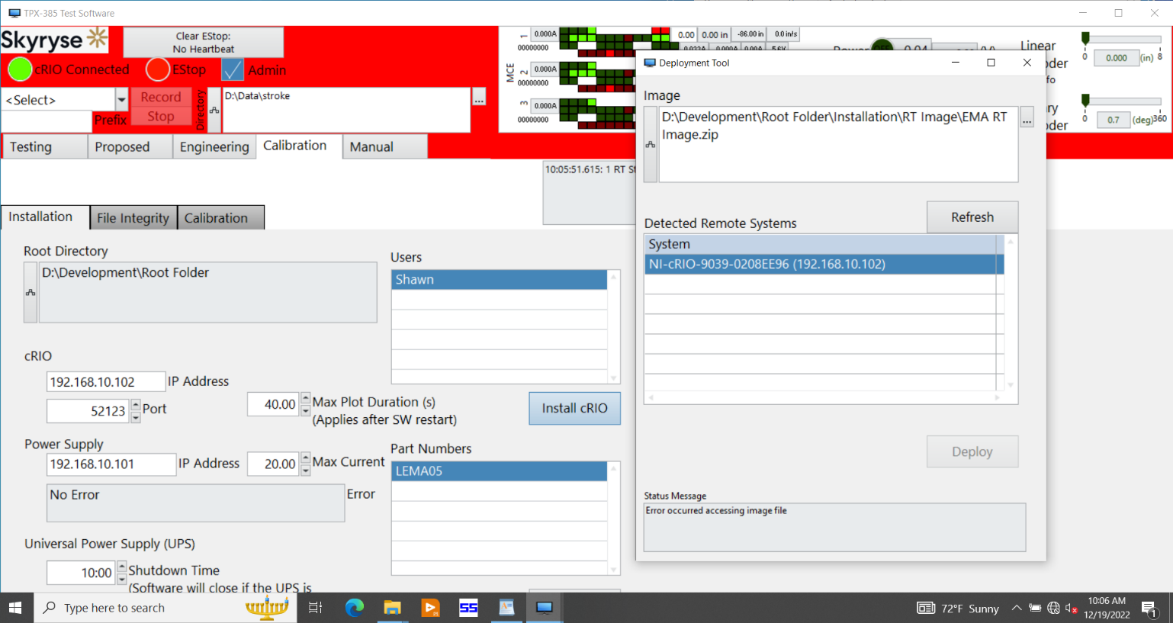

Figure 9 – cRIO directory

1. A ‘**Deployment Tool**’ window will appear, if the Image directory is not default from “**ProgramData**” click the three dots and select the proper file

“**C:\ProgramData\Bedrcok\Installation\RT Iamge\EMA RT Image.zip**”



Figure 10 – Deployment tool window

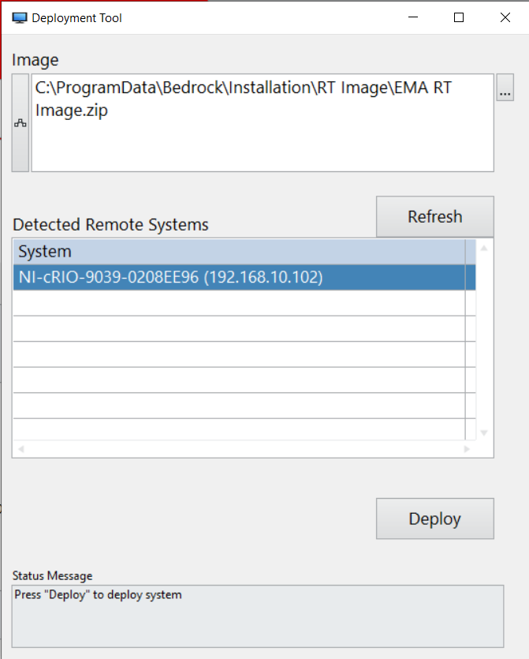

Figure 11 -Deployment Tool Correct path

### SCI – SureServoPro Installation

1. Naviagte and open the ‘SureServoPROInstall_V4’ file

Figure - File Explorer

1. Installer opens this window, and then bring up the InstallShield Wizard

Figure - InstallSheild Wizard

1. Select **‘Next’**

Figure - InstallsSheild Wizard

1. The License agreement will appear, select **‘Yes’**

Figure - License Agreement

1. Enter User Name and Company Name into the respective text boxes

Figure - Customer Infromation

1. The Install will then begin configuring, wait until it is complete and a new window appears

Figure - Setup Status

1. A popup box will ask you if you would like to create a desktop shortcut for SureServo PRO, select **‘Yes’**

Figure - Desktop Shortcut option

1. The Install will then complete, click **‘Finish’**

Figure - SureServo Install Completion

### SCI- Set computer IP address to Acopian default

1. Open Control Panel and select ‘View network status and tasks’

Figure - Control Panel

1. Select Ethernet 2 (or other) and a window will appear

Figure - Network and Sharing Center

1. Select **‘Properties’**

Figure - Ethernet 2 Status

1. Select Internet Protocol Version 4 and press Properties

Figure - Ethernet 2 Properties

Figure - Internet Properties

192.168.1.67

Subnet mask

255.255.255.0

Use Web browser to set Acopian Power Supply to 192.168.10.101

## Installation

## Computer SW (Done)

Run Installer and Download to cRIO

## Computer Settings

### Installing CDMS212

1. Select ‘CDM21364_Setup’

Figure - File Explorer

Figure

1. A driver window will appear click **‘Extract’** and then **‘Next’**

Figure 24- Device Driver Installation Wizard

1. Select **‘I accept this agreement’** then click **‘Next’**

Figure - User Agreement

1. Drivers will then begin installing

Figure -Driver installation

1. The installation will finish, click **‘Finish’**

Figure - Installation Complete

### ##Connection

1. Open device manager

Figure - Search Device Manager

1. Under **‘Ports’** ensure **USB Serial Port** is being read and take note of com port (COM3 in this case)

Figure - Device Manager ports

1. Open **SureServo PRO** and select **‘Connect to Drive’**, then **‘Go’**

Figure - Connect to Drive

1. Ensure Com Port is the same as above, if not select correct port. (COM3 in this case)

Figure - Com Port

1. Select highest **Baud Rate, (115200)**

Figure - Baud Rate 115200

1. Change **Protocol** to **‘8,0,1,MODBUS RTU’**

Figure - MODBUS

1. Click the arrow ‘**Upload’** button at the top of the window.

Figure - Upload

1. A verification window will appear, select **‘Yes’ to** accept override conditions.

Figure - Verification Window

1. (Needs a revision, couldn’t remember exact flow of data) after this the configuration will upload, then select ‘**File’,** then **‘Open’**

Figure - Current Config File

1. Go to **‘C:\ProgramData\Bedrock\Configuration’** and select **‘Sure Servo Config’** then select **‘Open’**

Figure - File Explorer

1. This screen will then appear as the file begins opening

Figure - SureServo using saved settings

1. The Monitor Parameters will be displayed followed by several warnings.

Figure - Monitor Parameters

1. A **Motor mismatch** and **Confirm Download** warning will appear, select **‘Yes’** on both.

Figure - Warning Windows

1. A window will then appear asking for a servo reset, select **‘Ok’**

Figure - Servo Reset

1. The servo will then reset, and configuration will be finished.

Figure - Basic Parameters

### Configure IP addresses

1. Open Window Settings for IP address, and set the **IP address to ‘192.168.1.65’**

Figure - Internet Protocol Version

1. Open your browser and type **‘192.168.1.100’** into the search bar, using **‘admin’** for both username and password when prompted.

Figure - Authorization Window

1. The Acopian Power Supplies window will now be shown, ensure ‘**OFF’** and ‘**LOCAL’** are selected, then select **‘configure network’**

Figure - Acopian Power Supplies

1. Set IP address to **‘192.168.10.100’,** and press set.

Figure - Acopian IP address

1. A window will appear, press **‘OK’**

Figure - Settings Saved

1. Go back to windows settings and change IP address to **‘192.168.10.65’** and select **‘OK’**

Figure - New IP address

1. Go back to the browser and change IP address to Set IP Address to **192.168.10.xx (where xx is less than 100),** and click ‘**Set’**

Figure - Setting new IP address

1. Select ‘**HOME**’ and then select ‘**REMOTE**’, IP confuguration is now complete

Figure - Changing Acopian to remote

## Sure Servo

1. Manually set the following parameters on the Sure Servo:

Using the **Mode, Next, and Arrow buttons** set the following parameters:

* P3.00: 1
* P3.01: 5
* P3.02: 08

1. Run Sure Servo
2. New Setup

## cRIO

No changes needed?

Figure

## Development Installation

This section describes how to install a computer for development.

